

Coahoma Agricultural High School

NEWSLETTER

Volume 2
Greetings Tiger nation,

We are always delighted to report to our parents the progress that we see our students make. We are well into the second nine weeks and we invite parents to come out anytime and observe students unleashing their true potential. We are building strong relationships that are woven through high expectations. The students of CAHS are among the best and brightest and we expect no less. Please continue to support us academically, athletically, and beyond.
Go Tigers!!!
“Aggie Clubbing It Up”

Meet the 2016-2017 Beta Club Members!!

Ba, Layesha
Boyd, Shalena
Coley, Jerome
Conrad, Destinee
Eutsey, Sammia
Foster, Dennis
Gardner, Marquita
Johnson, Anuya
Jones, Jerkerria
Jones, Tra’kedreya
Pollard, Leslie
Scott, Amber
Smith, Cartea
Taylor, George
Webster, Kanaka
Young, Ny’kalla
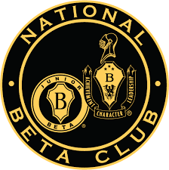

Principal Hardrict

November
News

“Taking education to the next level”
Important Dates
- PTO/Data night Monday November 14, 2016.
- Thanksgiving Break November 21st – 25th. Classes will resume Monday, November 28th.
- JMG Installation Program Tuesday, November 15th @ 9:30 a.m.
- Home basketball game Tuesday November 15th vs. Hollandale Simmons.
- Clarksdale High Invitational Basketball Tournament November 16th – 19th.
- Coahoma County Thanksgiving Tournament November 21st – 22nd.
- State Retest Dates: November 30th – December 7th

TEACHER OF THE MONTH

STAFF OF THE MONTH


Offices Wide
Coach Thomas

Principal Choice
Student of the Month
“We make Aggie look good”
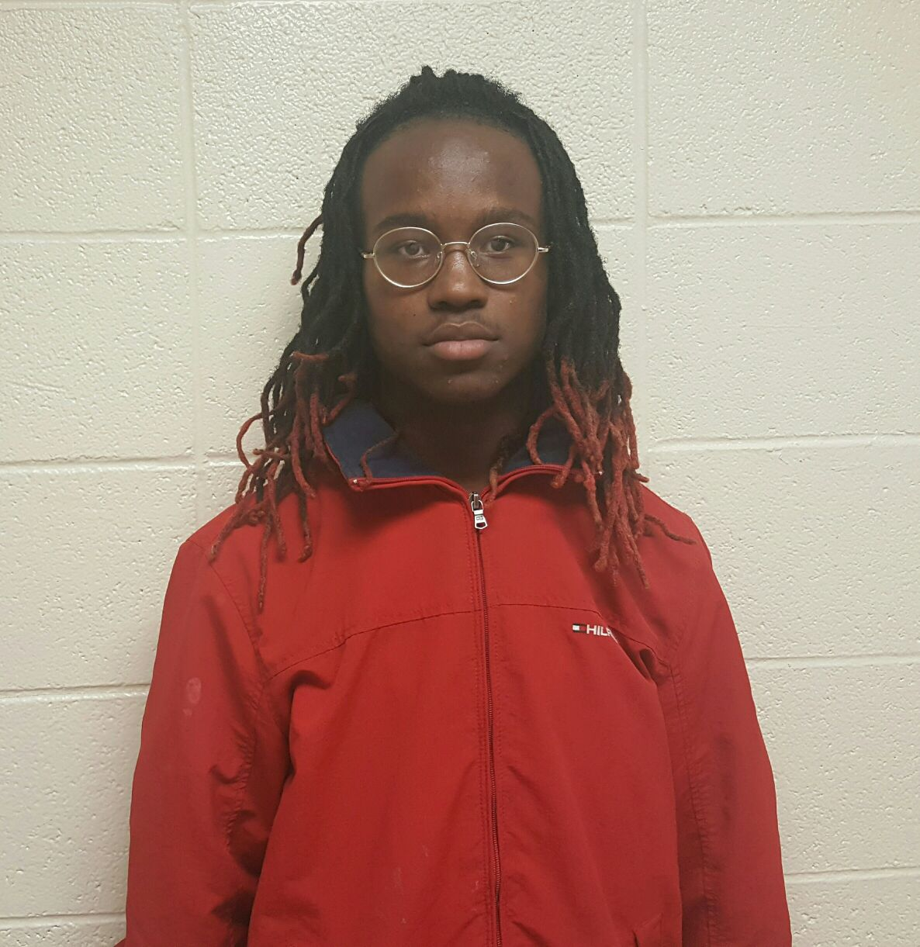
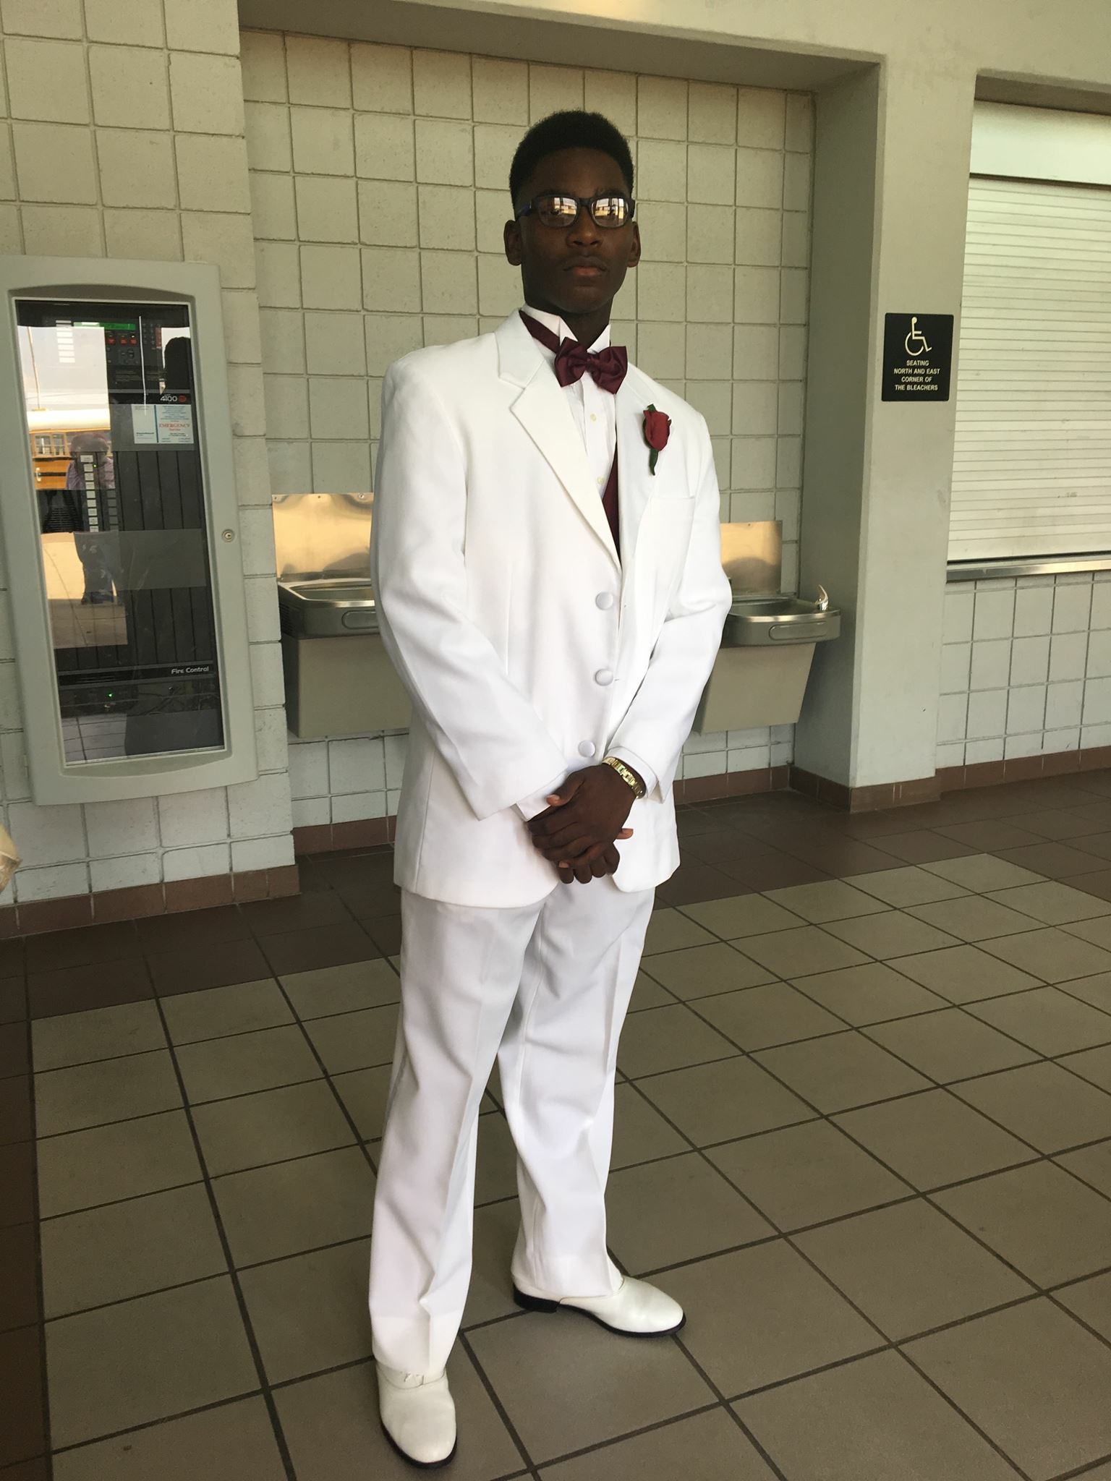

Jafaris Bryant
George Taylor

